Department of Computer Science and Engineering (Data Science)
CSDS-A | Batch A7 (CSE - Data Science, Section A)
SHEGUARD: AI Powered Women's Safety Platform
S.No. | Student name | Roll / hall ticket no.
1 | CH.AARTHI | 23K91A6741
2 | D.PRANATHI | 23K91A6748
3 | BALA VIGNESH | 23K91A6717
4 | A.VISHAL | 23K91A6704
Under the guidance of: [GUIDE NAME], [DESIGNATION]
DESIGN AND IMPLEMENTATION
This document describes the design of SHEGUARD and how it was implemented: the architecture, the modules, the database schema, the API, key code walkthroughs, and the reasoning behind the main implementation decisions.

1 System Architecture
SHEGUARD is a single-machine web application: a React progressive web app, a FastAPI back end, a SQLite database, one trained scikit-learn clustering model whose output is stored as a table, and a handful of free outside services. The abstract of the project names Flutter and Supabase; the implementation uses React and FastAPI with SQLite, and this chapter describes what was built. The figure below shows the layers.
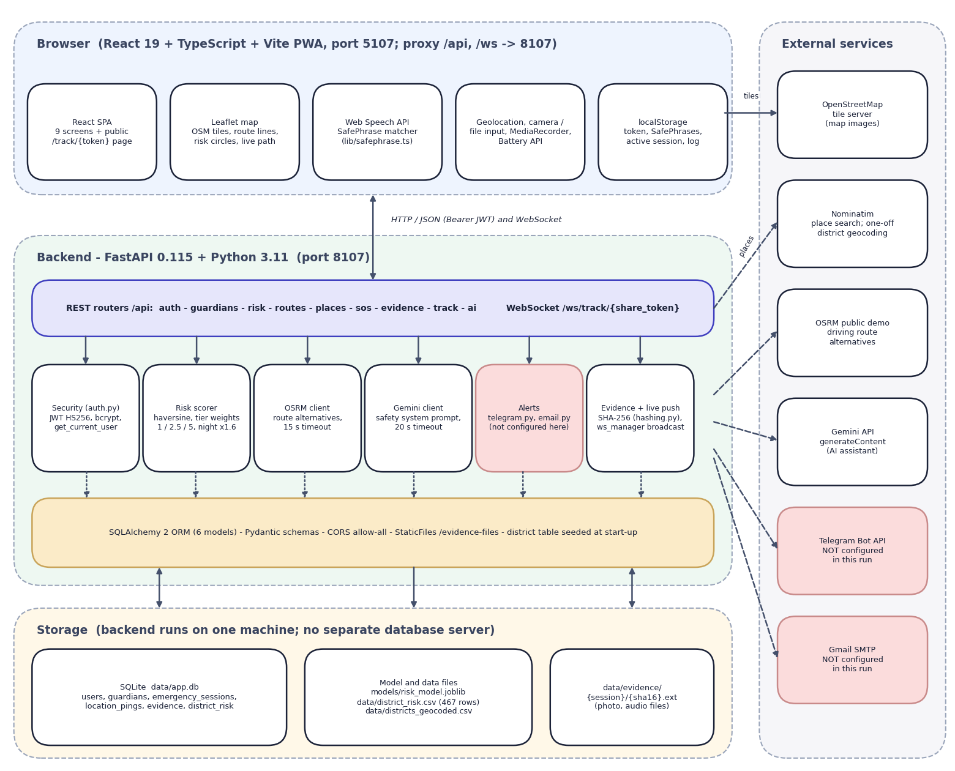
Fig. 1: System architecture of SHEGUARD
The diagram has four layers and a column of outside services. At the top is the browser: a React 19 and TypeScript single-page application built with Vite (port 5107, which proxies /api and /ws to the backend) and installable as a PWA. It contains the nine signed-in and signed-out screens plus the public /track/{token} page, a Leaflet map that draws OpenStreetMap tiles, route lines, risk circles and the live path, the Web Speech API with the SafePhrase matcher (lib/safephrase.ts), the device APIs (geolocation, camera or file input, MediaRecorder, battery), and localStorage, which holds the JWT, the SafePhrase list, the active session and a short activity log.
Below it is the FastAPI application on port 8107. Its ten routers (auth, guardians, risk, routes_plan, places, sos, evidence, track, ai and the WebSocket route ws) call six service blocks: security (bcrypt and HS256 JWT, get_current_user), the risk scorer, the OSRM client, the Gemini client, the alert senders (telegram.py, email.py) and the evidence and live-push helpers (hashing.py, ws_manager.py). SQLAlchemy maps six models to one SQLite file; the district table is seeded from data/district_risk.csv when the application starts. Storage is local: the database, the model and data files (risk_model.joblib and the two district CSV files) and the evidence folder. On the right are the outside services: OpenStreetMap tiles (called by the browser), Nominatim for place search, the OSRM public demo server for route alternatives, the Gemini API for the assistant, and the Telegram Bot API and Gmail SMTP for alerts. The last two are shaded because their credentials were empty in this run, so no alert was ever sent.
The design follows five principles. Keep guardians account-free: a guardian never logs in; the alert carries an unguessable 32-character link that opens a read-only page and a read-only WebSocket, so a frightened family member does not have to install or sign in to anything. Scope every query to its owner: guardians, sessions and evidence carry an owner or user identifier and every route compares it with the user in the JWT, which is this project's SQLite-compatible replacement for the Row Level Security named in the abstract. Treat alerts as best effort: each channel reports sent or not sent, the SOS itself never fails because an alert failed, and the screen shows exactly which guardians were reached. Keep the voice phrase on the device: the SafePhrase list is stored only in the browser, and only a SHA-256 fingerprint of each phrase is displayed. Be honest about the data: the planner screen states that routes are scored against district crime data from 2001 to 2012 and are a guide to the area, not live conditions.

2 Module Design
Table 1: Modules of SHEGUARD
Module | Code | Responsibility
Application | backend/app/main.py | Creates the FastAPI app, CORS (all origins), the /evidence-files static mount, table creation and the district seed at start-up, the /api/health route; includes the ten routers
Configuration and database | app/config.py, db.py | Reads .env (ports, JWT secret, keys, database URL), data and evidence folders; engine and session dependency
Security | app/auth.py | bcrypt hashing, HS256 JWT (7 days) creation and decoding, get_current_user
Models and schemas | app/models.py, schemas.py, seed.py | Six SQLAlchemy models, the Pydantic request types (password of at least 6 characters, email validation), the district seed
Auth and guardians API | routes/auth.py, guardians.py | Register, login, current user; guardian list, create, update, delete scoped to the owner
Risk and route API | routes/risk.py, routes_plan.py, places.py | Public district list; route planning (OSRM plus scoring); Nominatim place search for India, five results
SOS API | routes/sos.py, track.py, evidence.py, ws.py | Start, location push, cancel, read; evidence upload with SHA-256 and list; public track page; guardian WebSocket
AI API | routes/ai.py, services/gemini.py | Forwards a question and optional position to Gemini with a fixed safety system prompt (temperature 0.4, 400 output tokens, 20 s timeout)
Services | services/osrm.py, risk.py, telegram.py, email.py, hashing.py, ws_manager.py | OSRM client; haversine, tier weights and night factor; Telegram and Gmail senders (return False without credentials); SHA-256; viewers grouped by share token
Risk model | ml/train_risk_model.py, ml/eval.py | Aggregates 7 crime columns per district, StandardScaler and K-Means (k = 3), tier naming and 0-100 score, silhouette and Davies-Bouldin, route-scorer sanity check
Data scripts | scripts/download_data.py, geocode_districts.py, seed_demo.py, smoke_test.py | Dataset download, Nominatim geocoding (1 request per second), demo account, 12-step live smoke test
Tests and measurements | tests/, scripts/run_experiments.py, measure_api.py, safephrase_eval.mjs, assistant_eval.py | 57 pytest tests (51 pass, 6 expected failures that document defects); risk-model, route, API, SafePhrase and assistant measurements
Web application | frontend/src/ | 26 TypeScript files, about 2,950 lines: the App shell, ten screens, the navigation, the Leaflet map, three hooks (voice trigger, live location, battery) and five libraries (API client, geo helpers, SafePhrase matcher, siren, storage)

The browser, not the server, owns the SafePhrase feature, the three-second hold-to-cancel rule, the battery reading and the local siren (a three-second oscillator tone that never touches the network). The server owns authentication, data and every outside call except the map tiles.

3 Database Design
The database is SQLite, created by SQLAlchemy 2 at start-up with create_all; there are no migrations. Timestamps are stored in UTC. Uploaded photographs and audio clips are not stored in the database: they are files under data/evidence/{session id}/, and the table keeps the relative path, the SHA-256 hash, the kind, the capture position and the time.
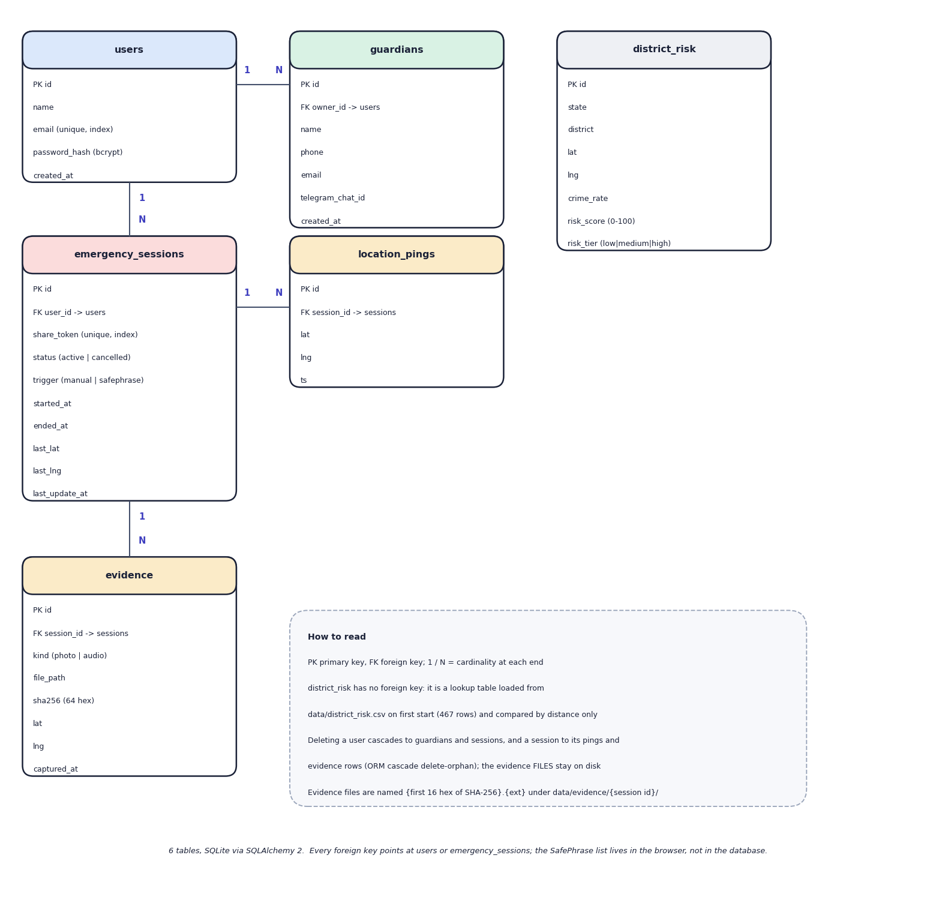
Fig. 2: Entity-relationship diagram (6 tables)
Six tables are created by SQLAlchemy in SQLite. A user owns many guardians and many emergency sessions; a session has many location pings and many evidence rows. The district_risk table is a lookup table with no foreign key: it holds the 467 geocoded districts with their crime rate, 0-100 risk score and tier, and is read by distance only. ORM cascades delete a user's guardians and sessions and a session's pings and evidence rows, but the evidence files stay on disk. The SafePhrase list is not in the database: it lives in the browser. The evidence.file_path column holds the path relative to data/, and the file name is the first 16 hexadecimal characters of the SHA-256 followed by the extension.
Table 2: Database tables
Table | Purpose | Key columns
users | Accounts | id, name, email (unique, indexed), password_hash (bcrypt), created_at
guardians | Trusted contacts of one user | id, owner_id (FK users), name, phone, email, telegram_chat_id, created_at
emergency_sessions | One emergency | id, user_id (FK users), share_token (unique, indexed, uuid4 hex), status (active, cancelled), trigger (manual, safephrase), started_at, ended_at, last_lat, last_lng, last_update_at
location_pings | The path of a session | id, session_id (FK), lat, lng, ts
evidence | Photo or audio of a session | id, session_id (FK), kind (photo, audio), file_path, sha256 (64 hex characters), lat, lng, captured_at
district_risk | Risk lookup loaded from the model output | id, state, district, lat, lng, crime_rate (crimes per reporting year), risk_score (0-100), risk_tier (low, medium, high); 467 rows

Four design points should be noted. First, status and trigger are plain strings checked only by the application: the API accepts any trigger text, which is one of the known gaps. Second, the share token is the only credential a guardian has, so it is generated with uuid4().hex and stored with a unique index; the tracking route returns 404 for an unknown token but the session never expires, and a cancelled session stays readable. Third, the evidence hash and the evidence path live in the same database, so the hash proves integrity only for someone who recomputes it from the stored file; no route does that. Fourth, the district_risk table is filled once, from data/district_risk.csv, and is not updated when the model is retrained unless the database is recreated.

4 Application Architecture
Fig. 3: System architecture of SHEGUARD
The back end is a FastAPI application. Routers in routes/ (auth, guardians, risk, routes_plan, sos, evidence, track, ai, places, ws) validate input and enforce ownership; services/ holds the logic that talks to outside systems or does the scoring (osrm, risk, gemini, telegram, email, hashing); SQLAlchemy models in models.py map to six SQLite tables; Pydantic schemas in schemas.py define request bodies; auth.py has password hashing, JWT creation and the get_current_user dependency; ws_manager.py keeps guardian WebSocket viewers grouped by share token. On start-up the application creates the tables and loads data/district_risk.csv into district_risk if that table is empty. Uploaded evidence is written under data/evidence/{session_id}/ and mounted read-only at /evidence-files.
The front end is a React 19 single-page application in TypeScript built with Vite. It has nine screens (landing, login, register, dashboard, safe routes, AI Guardian, SafePhrase, emergency, profile and guardians) and a public tracking page at /track/{token}. lib/api.ts wraps fetch, attaches the bearer token from localStorage and signs the user out on a 401; the hooks useLiveLocation (geolocation watchPosition, one push every 4 s), useVoiceTrigger (Web Speech API in continuous mode, restarted when the browser stops it), and useBattery provide device input; Leaflet draws the maps and the risk circles; Tailwind CSS 4 styles the interface; vite-plugin-pwa produces the manifest and service worker. SafePhrase phrases, settings and the recent-activity list are kept in the browser (localStorage) and never sent to the server, which learns only the trigger name (manual or safephrase) when an emergency starts. The Vite server on port 5107 proxies /api and /ws to port 8107.
Table 3: Technology stack of the implementation
Layer | Technology | Version
Language and runtime | Python; Node.js | 3.11.9; 24.19.0
Web framework | FastAPI with uvicorn | 0.115.6; 0.32.1
Database | SQLAlchemy over SQLite | 2.0.36
Machine learning | scikit-learn; pandas; NumPy; joblib | 1.5.2; 2.2.3; 2.1.3; 1.4.2
Security | PyJWT (HS256); bcrypt | 2.10.1; 4.2.1
Services | httpx client for OSRM, Nominatim, Gemini and Telegram; smtplib for Gmail | 0.28.1; standard library
Real-time | FastAPI WebSocket; websockets | 14.1
Front end | React; Vite; Tailwind CSS; Leaflet; TypeScript | 19.0.1; 6; 4.1; 1.9.4; 5.8
Size | Back end Python (backend/app); front end TypeScript (frontend/src) | 1,032 lines; 3,220 lines (26 files)
Machine used | Intel Core i5-12500 (6 cores, 12 threads), 15.7 GB RAM, Windows 11 Pro | no GPU used

The screens follow the lifecycle of an emergency. Dashboard: SOS button, guardian count, area risk at the current position, battery, SafePhrase status, recent activity. Safe routes: destination search, route map with the risk heat layer and route cards. AI Guardian: chat with the assistant. SafePhrase: phrases, test mode and sensitivity. Emergency: who was alerted, tracking link, live map, evidence buttons, hold-to-cancel. Profile: guardians (name, phone, e-mail, Telegram chat ID), sign-out and a fake-call screen.

5 API Design
The API is REST over JSON under /api: 19 HTTP endpoints and one WebSocket route, plus one static mount for evidence files. FastAPI serves interactive documentation at /docs. Every endpoint except health, registration, login, the public district list, the guardian tracking page and the evidence mount needs Authorization: Bearer <token>; the WebSocket is addressed by the share token alone. Errors have the form {"detail": "message"} with status 400, 401, 404, 422 or 502.
Table 4: API endpoints
Method | Path | Auth | Purpose
GET | /api/health | none | Liveness
POST | /api/auth/register | none | Create an account; returns a JWT and the user
POST | /api/auth/login | none | Returns a JWT and the user
GET | /api/auth/me | JWT | Current user
GET / POST | /api/guardians | JWT | List own guardians; add one (name, phone, e-mail, Telegram chat ID)
PUT / DELETE | /api/guardians/{id} | JWT, owner | Edit or remove a guardian; another user's id gives 404
GET | /api/risk/areas | public | 467 district rows with tier, score, rate and coordinates
POST | /api/routes/plan | JWT | OSRM alternatives scored and sorted; first is recommended; 502 if OSRM fails, 404 if no route
GET | /api/places/search?q= | JWT | Nominatim search restricted to India, five results
POST | /api/sos/start | JWT | New session and share token; guardian alerts; returns the tracking URL and delivery report
POST | /api/sos/{id}/location | JWT, owner | Store a ping and broadcast it; 400 once the session is cancelled
POST | /api/sos/{id}/cancel | JWT, owner | End the session and broadcast cancelled
GET | /api/sos/{id} | JWT, owner | Status, trigger, times, last position, evidence count
POST / GET | /api/sos/{id}/evidence | JWT, owner | Upload a photo or audio file (multipart, kind, optional lat and lng); list with hashes
GET | /api/track/{share_token} | token only | Read-only view for guardians: name, status, path, last position
WS | /ws/track/{share_token} | token only | Pushes location and cancelled messages
POST | /api/ai/ask | JWT | Question and optional position to Gemini; 502 on provider error
GET | /evidence-files/... | none (static) | Stored evidence files

Example: plan a route. The request carries two coordinate pairs; the response lists each alternative with its geometry, risk score and the tier counts of the sampled points:
Listing: Route request and response (shape)
POST /api/routes/plan
{"origin_lat": 28.6139, "origin_lng": 77.2090, "dest_lat": 26.9124, "dest_lng": 75.7873}
-> {"routes": [{"index": 0, "distance_m": ..., "duration_s": ..., "coordinates": [[lat, lng], ...],
"risk_score": 3.204, "risk_tiers": {"low": .., "medium": .., "high": ..},
"is_night": false, "recommended": true}, {...}], "safest_index": 0}

Example: start an emergency. POST /api/sos/start with {"lat": 17.385, "lng": 78.4867, "trigger": "safephrase"} returns session_id, share_token, tracking_url, started_at and a delivery list with one {guardian, telegram, email} entry per guardian. The WebSocket then sends {"type": "location", "lat", "lng", "ts"} messages and a final {"type": "cancelled"}.

6 Key Code Walkthroughs

6.1 Training the risk tiers
The three tiers are produced by a scaler and K-Means with a fixed seed; the cluster ids are then renamed by sorting the clusters on their mean crime rate.
Listing: Clustering and tier naming in ml/train_risk_model.py
X = data[["crime_rate"]].values
scaler = StandardScaler()
X_scaled = scaler.fit_transform(X)

kmeans = KMeans(n_clusters=N_CLUSTERS, random_state=RANDOM_STATE, n_init=10)
labels = kmeans.fit_predict(X_scaled)
data["cluster"] = labels

# Map cluster id -> risk tier by sorted mean crime_rate (ascending = low risk).
cluster_means = data.groupby("cluster")["crime_rate"].mean().sort_values()
tier_map = {cluster_id: TIER_NAMES[i] for i, cluster_id in enumerate(cluster_means.index)}
data["risk_tier"] = data["cluster"].map(tier_map)

# 0-100 risk score, min-max scaled within the fitted data.
rmin, rmax = data["crime_rate"].min(), data["crime_rate"].max()
data["risk_score"] = ((data["crime_rate"] - rmin) / (rmax - rmin) * 100).round(2)

6.2 Scoring a route
score_route samples the polyline, finds the nearest district for each sample, adds the tier weight (multiplied at night) and returns the mean.
Listing: Route score in backend/app/services/risk.py
def score_route(route, districts, sample_every_n=8, now=None):
"""Sample points along the route, map each to its district's risk tier, and
return an overall risk score (higher = riskier) plus the tier breakdown."""
now = now or datetime.now(timezone.utc)
night = _is_night_utc(now)
coords = route["coordinates"]
if not coords:
return {"score": 0.0, "tiers": {}, "night": night}

sampled = coords[::sample_every_n] or coords
tier_counts = {"low": 0, "medium": 0, "high": 0}
total_weight = 0.0
for lat, lng in sampled:
d = nearest_district(lat, lng, districts) if districts else None
tier = d.risk_tier if d else "medium"
tier_counts[tier] += 1
w = TIER_WEIGHT[tier]
if night:
w *= NIGHT_MULTIPLIER
total_weight += w

avg_weight = total_weight / len(sampled)
return {"score": round(avg_weight, 3), "tiers": tier_counts, "night": night}

6.3 Matching a spoken phrase
The matcher first tests whether the normalised transcript contains the phrase; otherwise it slides a window of the phrase's length over the transcript words and keeps the best share of matched words.
Listing: Phrase matching in frontend/src/lib/safephrase.ts
const spoken = normalizeText(transcript);
if (!spoken) return null;
const words = spoken.split(' ');
const threshold = SENSITIVITY_THRESHOLD[sensitivity];

let best: PhraseMatch | null = null;
for (const item of phrases) {
if (!item.enabled) continue;
const target = normalizeText(item.phrase);
if (!target) continue;
if (spoken.includes(target)) return { phrase: item.phrase, confidence: 1 };

const targetWords = target.split(' ');
let windowBest = 0;
for (let i = 0; i <= Math.max(0, words.length - targetWords.length); i++) {
const windowSet = new Set(words.slice(i, i + targetWords.length));
const hits = targetWords.filter((w) => windowSet.has(w)).length;
windowBest = Math.max(windowBest, hits / targetWords.length);
}
if (windowBest >= threshold && (!best || windowBest > best.confidence)) {
best = { phrase: item.phrase, confidence: windowBest };
}
}
return best;
}

6.4 Starting an emergency
start_sos stores the session and the first ping, builds the tracking link from the browser's origin, then tries every guardian on every configured channel and reports what was delivered.
Listing: Guardian alert fan-out in backend/app/routes/sos.py
guardians = db.query(models.Guardian).filter(models.Guardian.owner_id == current_user.id).all()

alert_text = (
f"SHEGUARD ALERT: {current_user.name} may need help "
f"({body.trigger} trigger). Live location: {tracking_url}"
)
delivery = []
for g in guardians:
sent_tg = await telegram.send_telegram_message(g.telegram_chat_id, alert_text) if g.telegram_chat_id else False
sent_email = email_service.send_email(g.email, "SHEGUARD emergency alert", alert_text) if g.email else False
delivery.append({"guardian": g.name, "telegram": sent_tg, "email": sent_email})

Delivery is attempted one guardian and one channel at a time. send_email is an ordinary blocking function inside an async route, so with real Gmail credentials it would hold the server's event loop for as long as each SMTP exchange takes (up to the 10 s timeout). The channels were never run with real credentials in this project.

6.5 Streaming a location to guardians
Each position update is stored as a ping and then broadcast to the WebSocket viewers registered under the session's share token.
Listing: Location push in backend/app/routes/sos.py
session.last_lat = body.lat
session.last_lng = body.lng
session.last_update_at = datetime.now(timezone.utc)
db.add(models.LocationPing(session_id=session.id, lat=body.lat, lng=body.lng))
db.commit()

await manager.broadcast(session.share_token, {
"type": "location",
"lat": body.lat,
"lng": body.lng,
"ts": session.last_update_at.isoformat(),
})

Listing: Broadcast in backend/app/ws_manager.py
async def broadcast(self, share_token: str, payload: dict):
conns = list(self._viewers.get(share_token, set()))
message = json.dumps(payload)
for ws in conns:
try:
await ws.send_text(message)
except Exception:
self.remove_viewer(share_token, ws)

6.6 Preserving evidence
The uploaded bytes are hashed before they are written; the stored file is named by the first sixteen characters of the hash and the row records the full digest, the kind, the time and the position.
Listing: Evidence hashing and storage in backend/app/routes/evidence.py
data = await file.read()
if not data:
raise HTTPException(status_code=400, detail="Empty file")

digest = sha256_bytes(data)
ext = (file.filename or "").split(".")[-1][:8] or ("jpg" if kind == "photo" else "webm")
session_dir = config.EVIDENCE_DIR / str(session_id)
session_dir.mkdir(parents=True, exist_ok=True)
filename = f"{digest[:16]}.{ext}"
path = session_dir / filename
path.write_bytes(data)

ev = models.Evidence(
session_id=session_id,
kind=kind,
file_path=str(path.relative_to(config.DATA_DIR)),
sha256=digest,
lat=lat,
lng=lng,
)
db.add(ev)
db.commit()
db.refresh(ev)

6.7 Pushing the live position from the browser
Listing: Throttled position push in frontend/src/hooks/useLiveLocation.ts
const watchId = navigator.geolocation.watchPosition(
(p) => {
const coords = { lat: p.coords.latitude, lng: p.coords.longitude };
setPos(coords);
const now = Date.now();
if (now - lastPush < 4000) return;
lastPush = now;
api(`/sos/${sessionId}/location`, { json: coords }).catch(() => {
// a missed ping is retried on the next fix
});
},
() => {
// permission or signal problems are shown on the emergency screen
},
{ enableHighAccuracy: true, maximumAge: 2000 },
);

7 Implementation Decisions and Reasoning
The table lists the main implementation decisions and the reason for each. Several follow from three constraints: no labelled safety data exist for individual streets, the project had to run on one ordinary computer without paid services, and the free external services (OSRM, Nominatim, Gemini) have no service guarantee.
Table 5: Implementation decisions
Decision | Why
K-Means [9], [10] on one feature instead of a multi-feature model | Only the district crime counts were available as open data; the base paper's population, police and socio-economic files were not used. K-Means gives data-driven tiers without labels; the cost, shown in Chapter 8, is that the model is two cut-offs on one number
Three tiers (low, medium, high), k = 3 | The interface shows three colours. The indices in Chapter 8 do not single out k = 3 (k = 2 has a higher silhouette, k = 4 a lower Davies-Bouldin value [11], [12])
Rate = total crimes / years reported | Districts reported between 1 and 12 years; averaging per reporting year keeps a district with few years comparable. Population was not available, so it is a count, not a per-capita rate
Drop districts that could not be geocoded | A wrong coordinate would put a risk circle in the wrong place; 467 of 827 were kept (56.5%) and the rest dropped instead of guessed. Geocoding ran once with Nominatim at one request per second and is cached in a CSV
Route risk = mean tier weight of every 8th route point (weights 1.0, 2.5, 5.0) | Cheap, explainable and independent of the routing engine; the weights are a judgement, and changing them to 1/2/3 or 1/3/9 changed no recommendation in the 10 multi-route pairs tested
Night multiplier of 1.6 between about 20:30 and 05:30 IST from the server's UTC clock | No per-user time zone was available; the result is that night scales every route equally and cannot change the ranking
OSRM public demo server for alternatives [17], Nominatim for place search | Free and needing no key; they have no service guarantee and OSRM often returns a single route
FastAPI, SQLAlchemy and SQLite [27] | Typed request models, automatic documentation, no database server to install; sufficient for one machine, but there is no row-level security and no migrations
JWT bearer tokens [19] and bcrypt [21] with an owner filter in every query | Stateless authentication; guardians have no account and reach a session only through an unguessable 32-hex token, so they need no app and no login in an emergency
WebSocket per session token [20] for live location | Pushes each position to every open guardian page without polling; the owner posts about every 4 seconds from watchPosition
SHA-256 [22] of every evidence file, computed on the server | Gives each file a fingerprint that changes if one bit changes; stored with time and location
Web Speech API [25] with a word-window matcher for SafePhrase | Needs no model or server of the project; the sensitivity levels set the share of the phrase's words that must be heard. It requires an open Chrome or Edge tab and online recognition
Phrases stored only in the browser, shown as a SHA-256 fingerprint | The server never learns the cover phrase; a user can confirm what is saved without displaying it
Gemini through the backend with a fixed safety system prompt [26] | The key stays on the server; the prompt demands that an emergency answer begins with SOS or emergency services and keeps answers under 150 words
React, Vite, Tailwind and Leaflet [28] as an installable PWA | One code base for phone and desktop; the abstract names Flutter and Supabase, which were not used
Telegram and Gmail alerts best-effort, reported per guardian | The SOS response lists what succeeded so the interface shows it; with no credentials every channel reports not sent

8 Security and Error Handling
- Passwords are hashed with bcrypt and a random salt; registration requires a valid e-mail address and a password of at least six characters (nothing stronger is required, aaaaaa is accepted).
- Tokens. A signed HS256 JWT [19] with the user id (sub) and a seven-day expiry; every protected route decodes it, loads the user and returns 401 for a missing, forged, tampered or expired token. The secret comes from .env; the code falls back to a development default only if none is set.
- Ownership instead of row-level security. Guardians, sessions, pings and evidence carry the owner's id, and every route compares it with the token's user: another user's session, guardian or evidence list returns 404 (confirmed by live probes and tests).
- Guardian access. Guardians never log in. They reach an emergency only through the 128-bit share_token in the link, which opens a read-only endpoint and a read-only WebSocket.
- Evidence. Only photo and audio kinds and non-empty files are accepted; the file is hashed with SHA-256 on arrival.
- Provider errors. OSRM, Nominatim and Gemini failures are caught and returned as 502 with a message; the front end replaces the raw error with a plain "unavailable" text.
Known gaps, found by testing and code review, stated so that they are not mistaken for features. Six are recorded as expected-failure tests (Chapter 7): (1) a Gemini read timeout is not caught and becomes HTTP 500 instead of 502; (2) coordinates are not range-checked (latitude 999 is accepted); (3) the trigger field accepts any string; (4) the WebSocket accepts any token, even one that matches no session; (5) there is no upload size limit (a 20 MB file was accepted in 0.24 s); (6) an .html file uploaded as a photo is served back as text/html from the API's origin.
Further weaknesses were found by probing or reading the code: stored evidence files can be fetched without a token (the file name needs the 16-hex hash prefix, so it is not guessable from the session id, but anyone with a link has the file); 25 wrong passwords in a row all return 401 with no lock-out; the tracking page keeps the whole location trail after the session is cancelled and never expires; CORS allows every origin; the blocking send_email call described in section 6.8; and .env, which holds the keys, is tracked by version control in this repository and must not be committed. The Telegram alert is sent with parse_mode HTML while containing the user's name, so a name with an angle bracket could make Telegram refuse it; this was read from the code and not tested. The hash of an evidence file lives in the same database as its path, and no endpoint recomputes it, so tampering is detectable only if someone does the comparison.

9 User Interface Design
The web application has a landing page, a log-in page and a sign-up page for visitors, and a sidebar layout for signed-in users with five destinations: Dashboard, Safe Routes, AI Guardian, SafePhrase and Profile and Guardians, plus a permanent red button that starts or reopens the emergency. On a phone the sidebar becomes a top bar with a small SOS button and a bottom navigation bar, and the route screen adds a floating SOS button. The dashboard shows the number of guardians, the risk tier of the nearest district, the battery level (or 'not shared by this browser'), the SafePhrase listening state, the large SOS button, shortcuts including a local siren, and the recent activity. The Safe Routes screen has a destination search box, a map with route lines and optional risk circles, one card per route with its distance, duration and the share of sampled points per risk tier, and a panel of three short AI tips for the selected route. The emergency screen shows who was alerted, the tracking link with a copy button, the live map, the evidence buttons and list, a call button and the hold-to-cancel button. The public tracking page shows only the person's name, the status, the map and a reminder to call the emergency number.
Design decisions follow from the situation. The emergency flow needs few taps, so the SOS button is always visible and a stray tap cannot end an alert because cancelling needs a three-second hold with a visible progress bar. Colour is paired with text (a risk badge says LOW, MODERATE or HIGH). Failures are shown in plain words: when the assistant is unavailable the screen says so instead of showing a provider error. The planner's disclaimer states that the scores come from 2001-2012 district data.
Two limitations of the interface are stated. The route screen asks the assistant for tips every time a route is selected, so each planning action also spends a Gemini request; and the emergency screen's call button reads 'Call 911' while India's emergency number is 112. The screens below were captured from the running application; the complete set is in Chapter 8 and Appendix C.
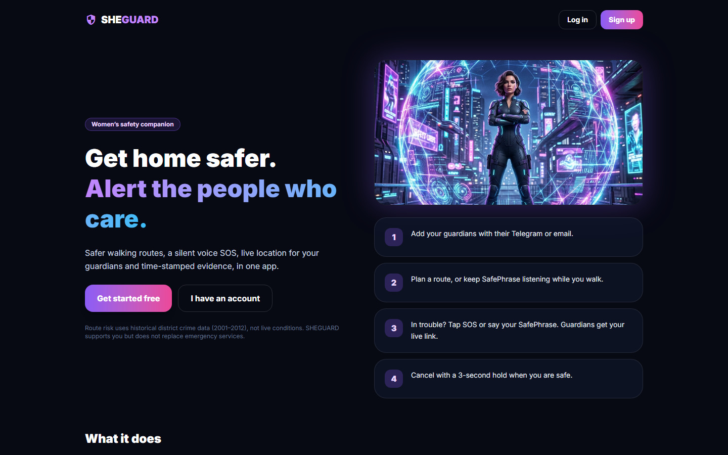  Fig. 4: Landing page for visitors | 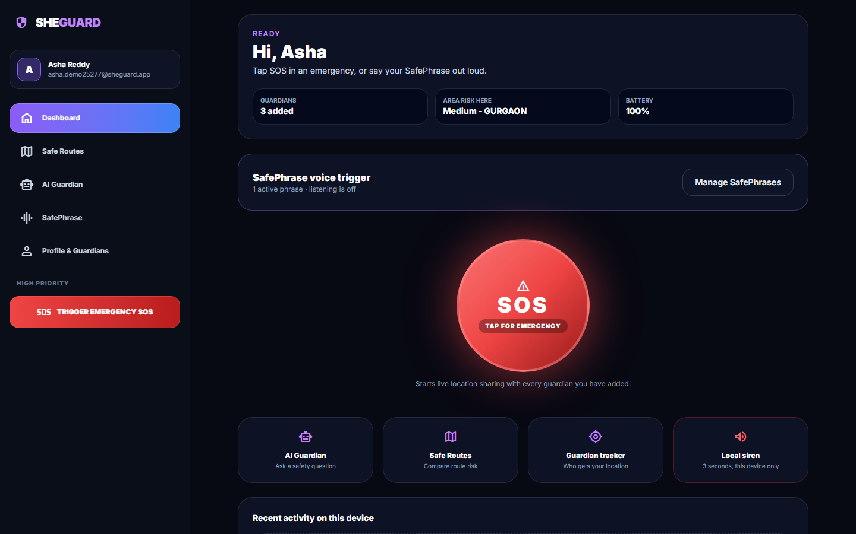  Fig. 5: Dashboard: SOS button, status tiles and SafePhrase state

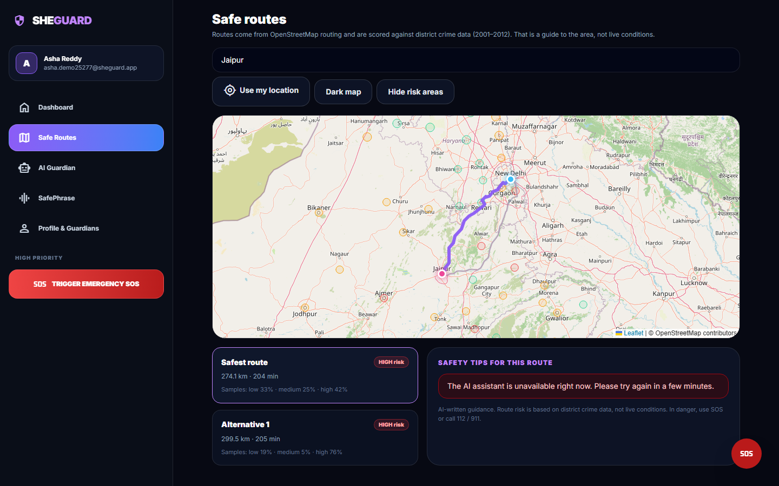  Fig. 6: Safe Routes: two alternatives scored by district risk | 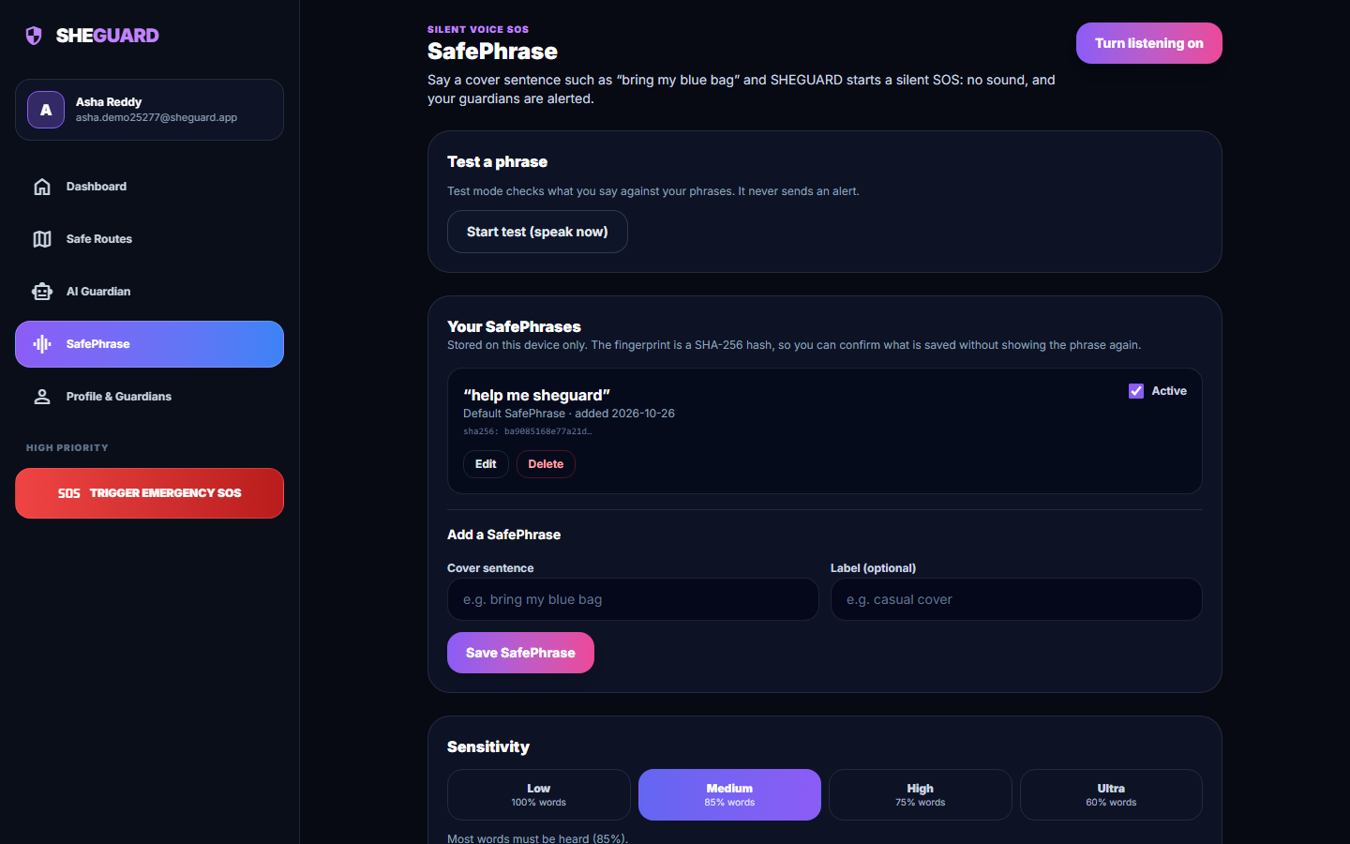  Fig. 7: SafePhrase settings: phrases, fingerprint, sensitivity

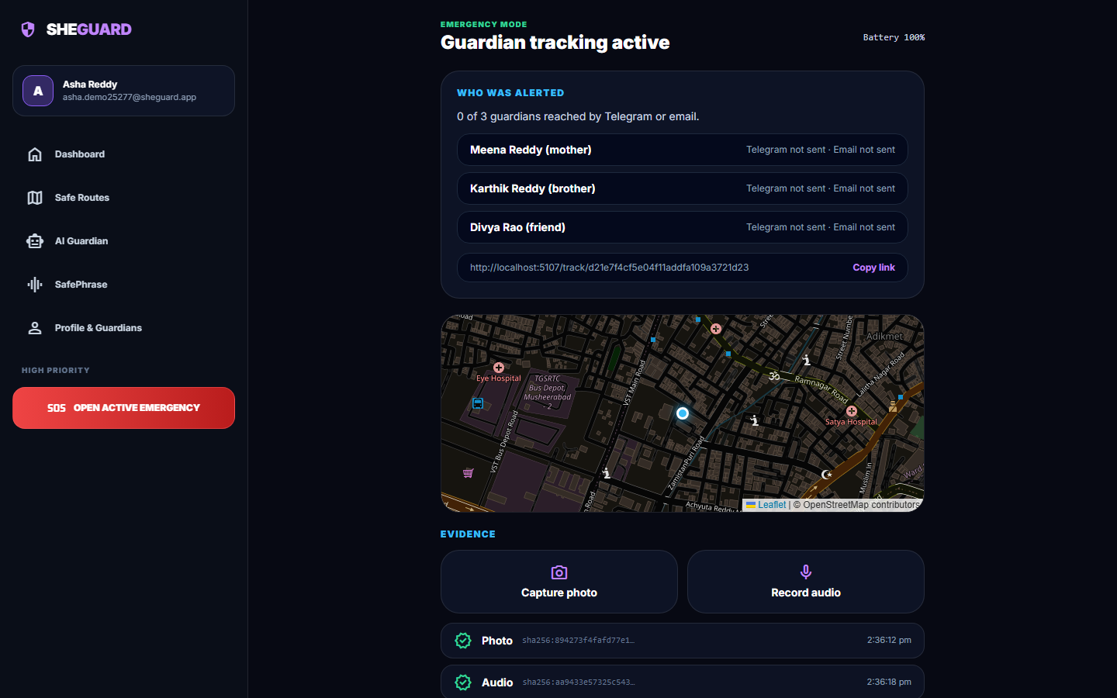  Fig. 8: Emergency screen with hashed photo and audio evidence | 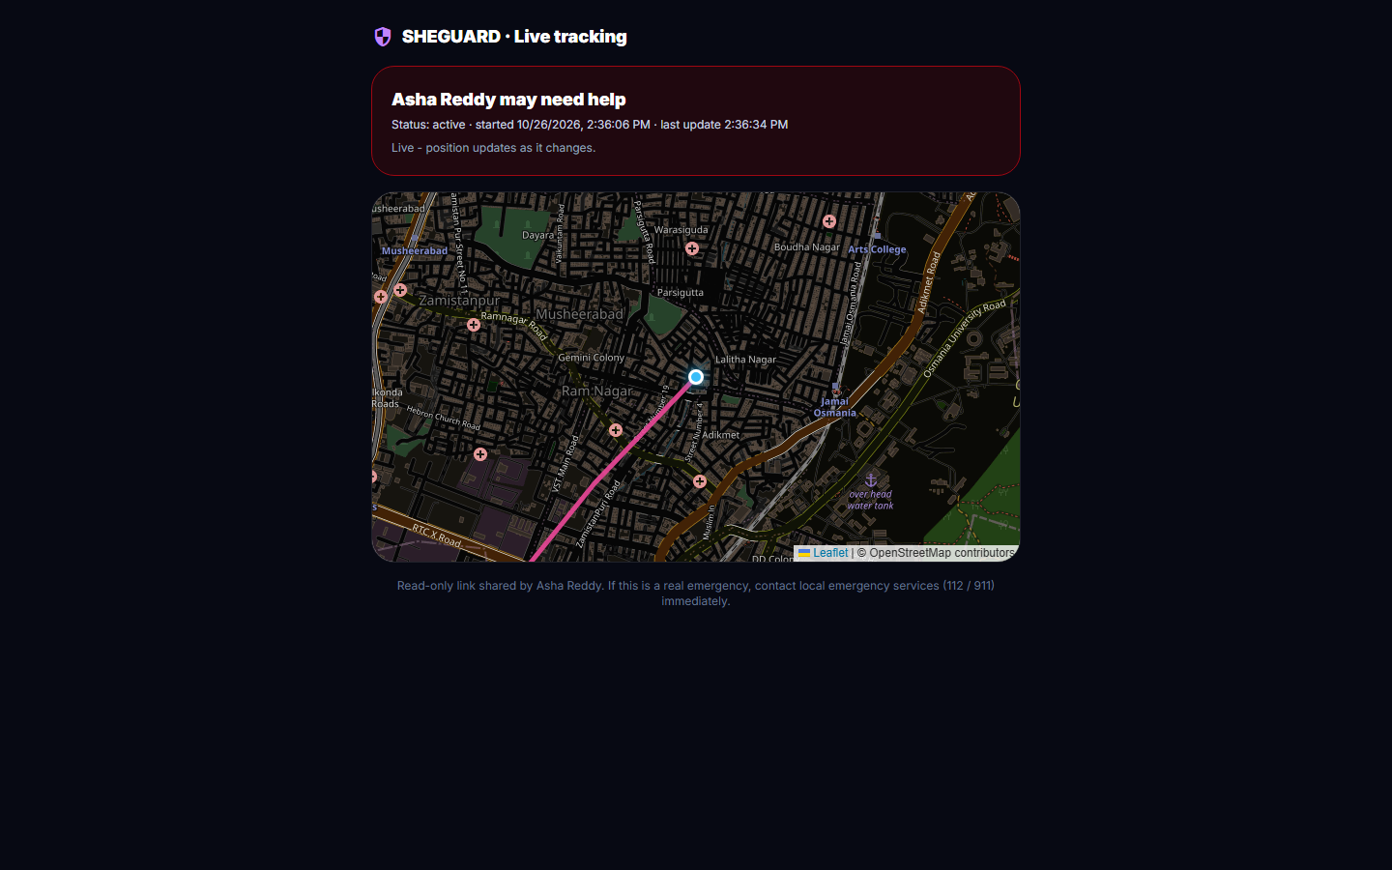  Fig. 9: Guardian's tracking page, no login

10 Installation and Execution
The application needs Python 3.10 or later (3.11.9 was used) and Node.js 18 or later (24.19.0 was used). All commands are run from the project folder 8.ProjectCode.
Table 6: Installation and execution
Step | Command | What it does
1 | setup.bat | Copies .env.example to .env if needed, creates venv, installs backend/requirements.txt, runs npm install in frontend/
2 | Edit .env | Set JWT_SECRET, GEMINI_API_KEY, TELEGRAM_BOT_TOKEN, GMAIL_ADDRESS, GMAIL_APP_PASSWORD; without the last three no alert is delivered, and without the first the assistant answers with an error
3 | venv\Scripts\python.exe ml\train_risk_model.py | Optional: rebuilds the model, data/district_risk.csv and experiments/metrics.json (committed copies already exist)
4 | run.bat | Starts the back end on port 8107 (uvicorn backend.app.main:app) and the Vite front end on port 5107, and opens the browser
5 | venv\Scripts\python.exe scripts\seed_demo.py | With the back end running, creates the demo account and one sample guardian
6 | venv\Scripts\python.exe scripts\smoke_test.py | Twelve live end-to-end steps against the running API
7 | venv\Scripts\python.exe -m pytest tests -q | The 57 automated tests (offline; uses a temporary database)
8 | run_experiments.py, measure_api.py, assistant_eval.py; node scripts\safephrase_eval.mjs | Regenerate the measurements in experiments/study/

docs/03_HOW_TO_RUN.md also describes phone testing through a Cloudflare quick tunnel (run_phone.bat); that path was not exercised in this documentation run. A browser with speech recognition (Chrome or Edge) is needed for SafePhrase, and Chrome asks for location, microphone and camera permission.
Table 7: Demo account created by the seed script
Account | E-mail | Password
Demo user | demo@sheguard.app | Demo@1234

Golden path. Register or log in, add two guardians on the profile page, open Safe routes and search a destination, open SafePhrase to check the phrase and sensitivity, press the SOS button, add a photo and an audio clip, open the tracking link in a private window, and hold the cancel button for three seconds.

